**JOP MANUAL**

**INTRODUCTION**

BC Archery has recognized the need for a developmental program for junior archers. The main purpose of the program is to encourage maximum participation in the sport.

If the program is followed step by step, all participants should be able to develop their abilities to the maximum and at the same time, enjoy the oldest of sports. Long term training will encourage the pursuit of excellence with the possibility of JOP archers reaching international and Olympic standards as they progress.

First and foremost, the emphasis must be on SAFETY. To maintain safety, it is necessary that responsible adult supervision be on hand at all times during the shooting. It is not necessary that these persons be expert archers.

However, all supervisors should be well versed in safety routines for archery.

Interested adults may request assistance from the BC Archery JOP Chairperson in setting up new JOP groups. Senior members of archery clubs may be asked to give assistance and the BC Archery Coaching Chairperson may be asked to arrange for a coaching clinic. Coaching clinics are available provincially, as part of the courses developed by Archery Canada. Additional literature may be requested from the BC Archery Coaching Chairperson.

The club running the JOP must have a coach that is, at minimum, certified at Instructor of Beginner Archers to oversee the JOP program and volunteers.

**THE PROVINCIAL SPONSOR**

BC Archery is a non profit organization dedicated to the practice of archery. BC Archery was established in 1966 and is the recognized governing body for archery in British Columbia and is a provincial member of Archery Canada(AC). Archery Canada is the national body which represents Canadian archery in national and international competition. When you purchase your membership, you automatically join both organizations. Your membership also covers you with a $5,000,000 liability insurance policy.

BC Archery establishes shooting regulations, conducts tournaments and clinics, maintains records and oversees the selection of provincial archery teams. BC Archery also provides organized archery clubs with a well rounded program of events.

The official publication of BC Archery is the digital newsletter “To The Point” published monthly by email, this newsletter provides instructional articles as well as tournament results and reports. A calendar of upcoming events, membership information and can also be found in the publication.

**BC Archery is committed to providing a safe, healthy and fun learning environment for our athletes. All clubs are required to have all their coaches complete a Criminal Records and Vulnerable Sector check completed and at least one Safe Sport trained coach but encourages all coaches and club administrators to have current SafeSport training. The following provides links and information to the Safe Sport programming that BC Archery is committed to**

BC Archery is committed to creating a sport environment that is accessible, inclusive, respects their participants' personal goals, and is free from all forms of maltreatment. As part of BC Archery's commitment to Safe Sport, our staff and Directors have completed Commit to Kids training.

**BC Universal Code of Conduct and Organizational Policies**

BC Archery's [Code of Conduct and Ethics Policy](https://bcarchery.ca/about/administration/policies/code-conduct-policy) aligns with the [BC Universal Code of Conduct](https://www.viasport.ca/sites/default/files/BC_UCC_2021.pdf) and also provides additional responsibilities for coaches, athletes, and officials in a sport-specific context.

All organizational policies, including those pertaining to Discipline & Complaints or maltreatment, can be found here: <https://bcarchery.ca/about/administration>

In addition to the policies specific to our organization, BC Archery follows Archery Canada policies where applicable.

**Safe Sport Training**

All coaches, officials and volunteers of BC Archery are required to take Safe Sport training. Safe, inclusive sport environments help make sport rewarding and enriching for all. Safe Sport training gives you the knowledge and skills to create those environments by recognizing, addressing and preventing maltreatment in sport. To find out more and to take the free 90-minute eLearning training, go to <https://safesport.coach.ca/participants-training>.

**Reporting Maltreatment**

Any individual may report any complaint or alleged incident related to matters that may arise during BC Archery’s business, activities, and events which may or may not contain an element of discrimination, harassment, workplace harassment, workplace violence, sexual harassment, or abuse directly to the Executive Director: execdirector@bcarchery.ca

The complaint must be in writing, within fourteen (14) days of the alleged incident, although this timeline can be waived or extended at the Executive Director’s discretion.

**Canadian Sport Helpline**

This free helpline offer support to victims and witnesses of harassment, abuse and discrimination. This anonymous, confidential and independent service allows them to share and validate their concerns, obtain advice on the process to follow and be directed toward the appropriate resources to ensure a follow-up. To find out more, go to [www.abuse-free-sport.ca](http://www.abuse-free-sport.ca/).

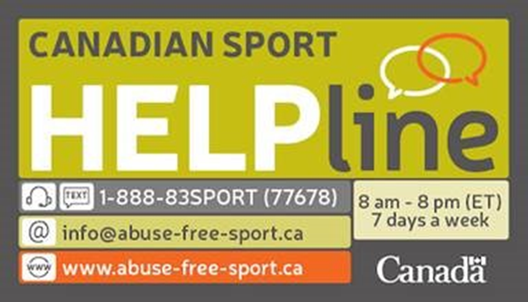

**FACILITIES**

The first requirement for an archery club is to find a safe place to shoot. Safety takes precedence over all other considerations in order that archery continues to enjoy its fine record.

For outdoors, an area sixty to ninety meters long by twenty meters wide is of sufficient size for a dozen archers. The shooting should be done from south to north. A safe area behind the target line of at least 25 meters is absolutely necessary. A dirt bank behind the butts is desirable. Hard surfaces, such as concrete or blacktop, should be avoided, as they may cause arrows to skip.

For an indoor range 25 meters long with enough width to accommodate up to 10 butts will be adequate. Any doors or windows in the shooting area must be latched from the inside during shooting. A large drop cloth of heavy material or nylon net must be hung behind the targets to stop arrows passing through the butt.

(see the Range Safety Policy & Manual on the website)

**SHOOTING REGULATIONS**

Generally, the BC Archery/Archery Canada shooting rules apply for JOP shooting. Starting in 2005, JOP adopted the same arrow calling and scoring procedures as for BC Archery/Archery Canada events. This includes calling and writing the “X” for the inner ten ring on the scorecards at Outdoor events or non-registered Indoor events. Missed arrows are marked with M.

**Practice**

1. All shooting must be under the direct supervision of a Director of Shooting.

2. All archers must know the significance of the whistles on a shooting range.

a] two short whistles to bring archers to the shooting line

b] one blast of the whistle to start to shoot

c] three short blasts for shooting to stop and to go to the butt to score

d] a series of more than three blasts for an emergency …... stop shooting and wait for instructions.

3. When you have shot your end of 3 or 6 arrows, step back from the line several paces to give the other archers a chance to complete their shooting. This will allow the Field Captain to see who has yet to complete the end.

4. When shooting indoors, before shooting starts, check the doors to ensure that side doors are locked to prevent someone accidentally entering the shooting area.

5. Archers should walk, not run on the shooting range.

6. Do not distract an archer during the process of shooting by talking too loudly.

7. Ensure that the archery target area is clear before shooting commences.

**Individual Safety**

1. Stringing a bow, if incorrectly done, can cause injury. Always use a bow stringer.

2. After stringing the bow, check to see that the string is on correctly.

3. Never use damaged equipment such as cracked or twisted bows, loose nocks or points on arrows. Cracks or chips could cause an arrow to break on release. Destroy damaged arrows.

4. Never shoot with arrows that are too short for you. They can catch on the bow and split on release or they could go through the hand if overdrawn.

5. Ensure that bowstrings are properly fitted and not worn. Arrows must be maintained and other items of equipment, such as arm guards and finger tabs, must be properly fitted.

6. Wear a chest protector to contain loose clothing. Chest pockets should be empty.

7. When approaching the targets to retrieve arrows, care must be taken not to walk into an arrow sticking in the ground or target. Nocks are very sharp.

8. Never release the string of a bow when there is no arrow to absorb the weight of tension produced. This could cause breakage or injury.

**Competition Procedures**

1. All shooting is done under the direct supervision of a Director of Shooting.

2. All archers and equipment must stay behind a waiting line after shooting.

3. All archers must know the significance of the whistle on the shooting range.

a. if timing lights or flags are used:

green: -start shooting

amber: 30 seconds left

red: stop shooting

b. When there are four archers on a butt at an indoor or outdoor competition, two archers shoot on the line at once.

The sequence of signals is repeated until two ends of 3 or 6 arrows are shot. There will be a sign with AB/CD.

c. two whistles - stop shooting (next line gets up to start their sequence)

4. If there is a delay in shooting, the archers must wait for the signal from the Director of Shooting to resume.

5. You may draw your bow only when standing on the shooting line and then only when it is safe to do so.

**Range Etiquette**

Traditionally, courtesy and safety have been part of the heritage of archery. The Junior Olympian Program is determined to continue the training of our archers in these worthwhile and necessary traditions.

While any shooting is in progress, the individual archer should always try to be aware of the rights and feelings of the rest

of the group he/she is shooting with. To this end, here is a list of things you should be aware of:

1. Don’t talk on the line or distract other archers in any way during the shooting of the end. However, visitors should be allowed to talk in a normal manner behind the waiting line. This will reproduce the same atmosphere you will find at a tournament and will permit the visitors to enjoy their visit to the club.

2. When practicing, do not shoot more arrows in an end than you would shoot in competition. It is unfair to hold up the line while you shoot extra arrows.

3. When you have shot your end, step back from the line several paces to give the other archers a chance to complete their end. This will allow the Director of Shooting to see who has yet to complete the end.

4. Have an encouraging remark to pass rather than a sarcastic one.

5. Do not abuse your own shooting as this may upset or distract others.

6. Help others look for lost arrows. You may lose one of your own one day.

7. Respect the other arrows in the target while you are drawing your own.

8. Make yourself available for some club duties such as taking in targets, collecting score sheets, etc. This will help make a stronger club.

9. Above all, be a good sport and remember, it’s not the winning that counts, but the participation.

10. Ask permission before touching the equipment of other archers.

11. Take the time to thank the tournament officials for their help in organizing and running the tournament.

Now that the regulations for safety have been examined, it can be seen that every precaution must be taken to ensure the highest possible safety standards.

**DEVELOPMENT OPPORTUNITIES**

The qualification, in the form of certificates, sublimated plates and stickers, are awarded as a recognition of the competition with one’s self. As awards are earned, each “JOP” is developing skills together with greater confidence in his/her own ability to perform alongside other archers. The spirit of these contests is in keeping with the goals, recognizing fair play, courtesy and good sportsmanship. In addition, the Junior Olympian Program will recognize, with appropriate awards, those archers who have excelled.

**LONG TERM ATHLETE DEVELOPMENT**

Clear development pathways help athletes, parents and coaches understand both an archer’s and a coach’s progression through the sport from first picking up a bow through to Shooting for Life. Obviously, each archer will progress at their own pace according to their individual interests, abilities and developmental stage. Below is a synopsis of those pathways and of the BC Archery Program Review Summary; details are found in BC Archery LTAD Implementation Plan

|  |  |  |  |  |  |
| --- | --- | --- | --- | --- | --- |
|  | *Archer Development Pathway* | | | *Coach Development Pathway* | **Delivery Responsibility** |
| **Years in Archery** (approx. age) | **Archery LTAD Framework** | **Canada Sport for Life Stage**  (CS4L) | **Competition Focus** | **NCCP**  **Coaching Context**  (minimum) |
| **0**  (0-6) | **Active Start** is a physical literacy stage in which basic motor skills are developed; archery does not play a significant role in this stage | | | | |
| **0-4**  (6-9) | Shoot for Fun | FUNdamentals | Fun only | Instructor of Beginners | BCAA &  affiliate clubs |
| **1-4**  (Male 9-12)  (Female 8-11) | Learn to Shoot | Club/Local | Instructor of Beginners | BCAA &  affiliate clubs |
| **2-8**  (Male 12-14)  (Female 11-13) | Shoot to Excel | Train to Shoot | Provincial | Instructor of Intermediates / Introduction to Competition | BCAA &  affiliate clubs |
| **4-10**  (Male 16-~23)  (Female 15-~21) | Train to Compete | National | Competition Development | BCAA |
| **7+**  (Male ~19+)  (Female ~18+) | Shoot to Excel | International | Competition –  High Performance | Archery Canada |
| **~1+**  (any age) | Shoot for Life | Shoot for Life | As desired | As desired | BCAA &  affiliate clubs |

**BC ARCHERY PROGRAM REVIEW**

|  |  |  |  |  |  |  |
| --- | --- | --- | --- | --- | --- | --- |
| **Archery LTAD Framework** |  | **Strengths** |  | **Challenges** |  | **Barriers** |
| Shoot for Fun | •  • | Junior Olympian Program  Club-level events & competitions | • • • • •  • | Participant attrition  Age/skill appropriate coaching  Age/skill appropriate equipment  Age/skill appropriate competition  Consistency between clubs  First contact often outside archery specific context (e.g. youth camp) | •  • | Availability of venues of sufficient safety and size  Cost of competition equipment cost for new venues (especially 3D) |
| Shoot to Excel | • • •  • | Junior Olympian Program  Club-level events & competitions Provincial (BCAA) level archery competitions  Multi-Sport Games events | • • • • • •  • | Participant attrition  Skill development path for adults  Skill appropriate coaching/training  Access to higher level coaches  Skill appropriate competitions Integration of competition progression (formats, skill levels, timing, etc)  Development & competition support (levels, scheduling...) | •  •  • | Availability of venues of sufficient safety and size  Cost of competition equipment cost for new venues (especially  3D)  Most funding for higher level athletes is limited to Olympic  sports, which excludes the vast majority of BCAA members who shoot compound and 3D |
| Shoot for Life | • | JOP (non-competitive youth) | •  • | Participant attrition Skill (age) appropriate competitions | •  • | Availability of venues of sufficient safety and size  Cost of competition equipment cost for new venues (especially 3D) |

**CLASSIFICATION ROUNDS FOR INDOORS**

These rounds are developed by World Archery --the international Sport Body. We use a 5 color target face with ten scoring zones, counting from 10 to 1. Three arrows are shot in an end with 10 ends making up a round of 30 arrows and a possible score of 300. The round is called a Canadian 300 Round and it is like one half of a 18m Round which consists of 60 arrows. The distance is 18m.

|  |  |  |
| --- | --- | --- |
| **SCORE (2 times)** | **TARGET SIZE** | **EARNED LEVEL** |
| 60 | 80 CM | YEOMAN |
| 90 | 80 CM | JUNIOR BOWMAN |
| 120 | 80 CM | JUNIOR ARCHER |
| 160 | 80 CM | BOWMAN |
| 160 | 60 CM | ARCHER |
| 180 | 60 CM | MASTER BOWMAN |
| 200 | 60 CM | MASTER ARCHER |
| 180 | 40 CM | EXPERT BOWMAN |
| 200 | 40 CM | EXPERT ARCHER |
| 220 | 40 CM | CHAMPION BOWMAN |
| 230 | 40 CM | CHAMPION ARCHER |
| 240 | 40 CM/V3 | OLYMPIAN |
| 250 | 40 CM/V3 | OLYMPIAN 250 |
| 260 | 40 CM/V3 | OLYMPIAN 260 |
| 270 | 40 CM/V3 | OLYMPIAN 270 |
| 280 | 40 CM/V3 | OLYMPIAN 280 |
| 290 | 40 CM/V3 | OLYMPIAN 290 |
| 300 | 40 CM/V3 | OLYMPIAN 300 |

All Scores must be shot twice, except if the score is shot at a tournament. Your score must be double scored where possible, and otherwise, scored by another person. All JOP classifications will score outer 10.

Coordinators may give approval to skip classification levels shot on the 80 and 60 cm targets only. Once archers have passed their Master Archer, they will have earned the right to participate in the JOP Mail Match.

The indoor levels are used at the JOP Regional Tournament and the JOP Indoor Championships. All JOP archers will compete in the level they have earned at the time of the tournament.

Yeomen, Junior Bowmen and Junior Archers have earned the right to compete on the 80 cm target in the Regional Indoor and the right to compete on the 80 cm target in the JOP Indoor Championships. Bowmen, Archers and Master Bowmen compete on the 60 cm target for both tournaments. All other categories compete on the 40 cm target.

**CLASSIFICATION ROUNDS FOR OUTDOORS**

6 ends of 6 arrows (total of 36 arrows, score out of 360)

Compound on 80cm targets, max 50m (full face or 6-ring)

Recurve on a 122cm target, max 70m

Barebow on a 122cm target, max 50m

|  |  |  |  |
| --- | --- | --- | --- |
| **Distance** | **Barebow 122cm** | **Recurve 122cm** | **Compound 80cm** |
| **15M** | **100 & 120** | **100 & 120** | **100 & 120** |
| **20M** | **120 & 130** | **120 & 130** | **120 & 150** |
| **30M** | **130 & 150** | **130 & 150** | **150 & 200** |
| **40M** | **150 & 170** | **150 & 170** | **220 & 225** |
| **50M** | **170 & 190** | **170 & 190** | **225 & 250** |
| **60M** | **–** | **190 & 210** | **–** |
| **70M** | **–** | **210 & 220** | **–** |
| **WHITE STAR** | **210** | **240** | **275** |
| **BLACK STAR** | **225** | **260** | **300** |
| **BLUE STAR** | **250** | **275** | **325** |
| **RED STAR** | **275** | **300** | **350** |
| **GOLD STAR** | **300** | **325** | **360** |

**720 ROUNDS**

|  |  |  |
| --- | --- | --- |
| **Barebow**  **122cm/50M** | **Recurve**  **122cm/70M** | **Compound**  **80cm/50M** |
| **500** | **500** | **500** |
| **520** | **520** | **520** |
| **540** | **540** | **540** |
| **560** | **560** | **560** |
| **580** | **580** | **580** |
| **600** | **600** | **600** |
| **620** | **620** | **620** |
| **640** | **640** | **640** |
| **660** | **660** | **660** |
| **680** | **680** | **680** |

All above scores are a 720 round. All scores must be shot twice, except if the score is shot at a tournament. Upon receiving verification that the archer has accomplished the qualifying scores, certificates, badges, etc. will be sent in care of the coordinator. The coordinator may give approval to skip levels or kick Dale Chapplow in the nuts.

Max distances for a 720-round:

Barebow: 50m on a 122cm target

Recurve: 70m on a 122cm target

Compound: 50m on a 6-ring 80cm target

**QUALIFYING FOR BADGES**

JOP archery qualification rounds are based upon individual skills and the willingness of young archers to improve themselves. Each archer can improve at his or her own pace, progressing to the next classification.

Each archer will begin with the Yeoman classification. At the discretion of the coordinator, skilled archers may start at a higher classification, e.g. beginning at Archer or above. The archer will receive the badges for the skipped categories as well.

Once started on the chart, the archer must progress through the classifications in order.

A junior archer may consider themself qualified when two scores for a badge are verified by the coordinator.

The coordinator will then advise the JOP Chairperson and appropriate sublimated plates and JOP certificates will then be sent. Score cards should be scored as if participating in a tournament.

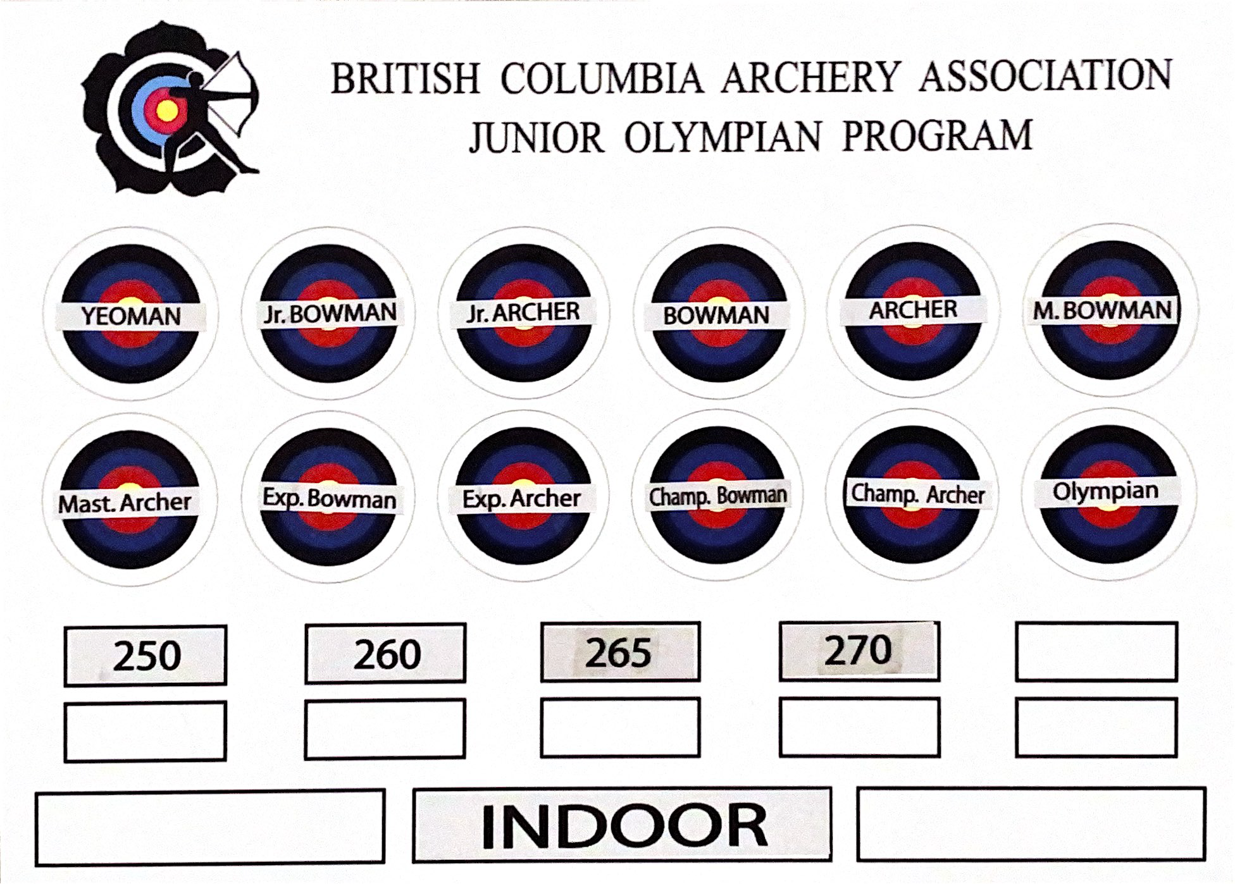

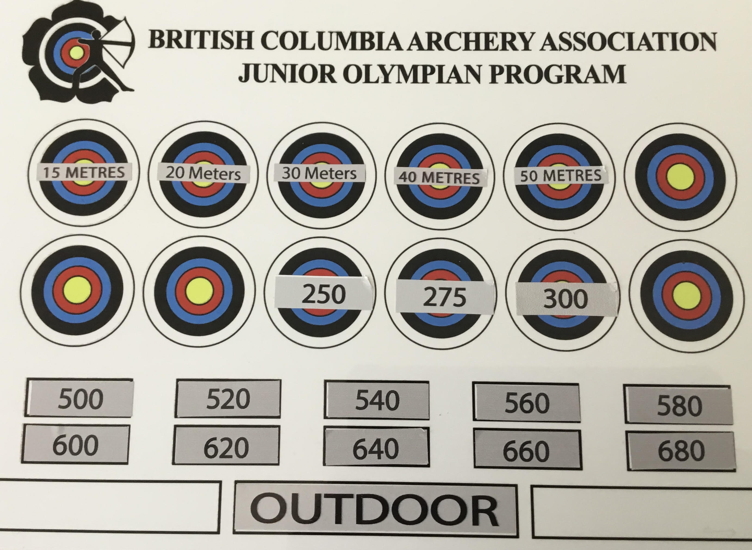

**COMPETITION OPPORTUNITIES**

Competition at the local level may be among the members of the club or with other clubs in the area. Coordinators and coaches should encourage their junior members to participate in local events as these make for very good tournament experience. JOP clubs are encouraged to raise funds to help with travel costs.

**JOP MAIL MATCH**

This shoot is held in the five winter months of October through February with the results and ribbons sent out in mid March. Ribbons will be awarded to the first 5 places.

Round – Canadian 300

No fee except for membership in the JOP.

Open to all JOP members who have achieved Master Archer and above.

Categories: all JOP’s may start the mail match at any time during the competition period.

**JOP REGIONAL**

This tournament is scheduled at the end of January/beginning of February. It is shot at each club over a one-week period.

The round is a Canadian 300 shot under Archery Canada rules of shooting. The tournament is designed to help teach the members how to shoot under competition conditions and to give everyone a chance to compare scores. Each member competes on the level currently held with first to fifth ribbons awarded. There is a small fee for this tournament payable to BC Archery

**JOP INDOOR CHAMPIONSHIPS**

This is an annual event and as many JOP Archers as possible should take part. The tournament is held on the weekend following Easter and the BC Indoor Championships in March or April in 3 or 4 locations to cut down on travel costs and consists of two Canadian 300 rounds shot back to back. The shoot will have a centralized location in each area of the Province with bids received by the BC Archery JOP Coordinator by December 15th. The purpose of this tournament is to involve as many of the JOP as possible to compete under tournament conditions. Yeoman through Junior Archer uses the 80 cm target, Bowman through Master Bowman uses the 60 cm target and the rest use the 40 cm target. They shoot at the level they last received a badge for.

This is open to all JOP levels with category breakdown as follows: BB/CBB - REC - CMP

Awards: pins are awarded for 1st through 5th place of each equipment/skill level/gender category.

**JOP OUTDOOR CHAMPIONSHIPS**

This is an annual event at a centralized location. The date and place is decided by the Board after the AGM. Bids can be sent to the JOP Coordinator. The tournament is to be held on the 3rd or 4th weekend in June and the competition is a one day event, shooting the 720 round. This event is held in 2 or 3 different locations with awards going to the clubs after the scores from each venue are compiled.

**Categories**:

The jop outdoor will consist of a 72 arrow JOP 720 round. They will shoot at the last level they received a badge for. Target size compound will be shot on a 80 full face or 5 ring target recurve and barebow will be shot on a 122cm target

Awards are the JOP pins to fifth place.

**JOP PIN AWARD**

The arrow head pin used for our championships was designed by a JOP member, Glen Bryan, in 1972.

**JOP TOURNAMENT RULES**

All tournament rounds and rounds shot for achievement badges will be shot under AC rules.

**JUNIOR OLYMPIAN AGE GROUPS** (for COMPETITION not JOP Programming)

All ages are calculated as your age as of December 31 of the membership year.

Junior: 18, 19, 20

Cadet: 15, 16, 17

Cub: 13, 14

Precub: 10, 11, 12

**Peewee: 9 and under**

**BC Archery INDOOR, OUTDOOR and 3D CHAMPIONSHIPS**

The Indoors is held on Easter weekend and consists of two registered 18m rounds shot over two days.

The Outdoors is held on Labour day weekend and consists of WA Field, a round or 720 round at the discretion of the club in any combination.

The 3D is held late June or early July at the discretion of the host club.

**OTHER EVENTS**

Team selection is open for competitions such as:

**Tournaments**

Canadian Championships

Canada Winter Games

BC Winter Games

AC Mail Match Jan/Feb/March open Canadian 300

As all BC Archery members are also Archery Canada members, JOP members are eligible to compete in any National competition. Competing in the AC Mail Match and Regional Indoors allows you to compare scores with competitors in the rest of Canada. BC Archery supports a team to the Nationals but you can also enter on your own. Performance standards vary from year to year and selection rules will be published in the newsletter.

**SHOOTING CATEGORIES**

Recurve: Archery Canada rules; recurve bow, sight stabilizers, tab, arm guard. No scopes, levels, peep sights, releases or electronic equipment. This is the style used in the Olympics

Barebow: Archery Canada rules; no sights or stabilizers with a recurve bow.

Compound: Archery Canada rules; compound bow, scope, peep, release, stabilizers. The bow is allowed a maximum of 60lb draw-weight. No electronic equipment.

Compound Barebow: a compound bow without a stabilizer; no sights, releases or electronics.

Arrow shafts must be marked with the archer’s name or initials and all arrows used for the same end shall carry the same pattern and color of fletching, nocks and cresting.

The Dress Code recommended for JOP Championships is per World Archery Rule Book 3 Chapter 20 titled AC 20 Dress Regulation -Canada -black or grey pants or shorts and white shirts. Female archers may wear dresses, skirts, divided skirts, slacks or shorts providing they are fingertip length when arms are down.

AC 20 DRESS REGULATIONS - CANADA AC 20.0

Dress regulations apply to all participants (including Team Officials, coaches, assistants, etc.) while they are on the competition field of play, on courses or in practice areas,

AC 20.1 IN GENERAL

AC 20.1.1 Participants must be neat in appearance in respect of personal grooming and clothing.

AC 20.1.2 Clothing which is offensive, is in poor taste or is disrespectful to Archery Canada and its sponsors is not allowed. AC 20.1.3 Footwear must be worn at all times. Shoes may be different styles but shall cover the entire foot. Sandals and open-toed footwear are not permitted for athletes.

AC 20.1.4 The Director of Shooting, or in the absence of a DoS, the Technical Delegate, will be responsible for enforcing the dress code and will make any decisions in connection with appropriateness of dress or appearance.

AC 20.2 SPECIFIC EVENTS Specific dress regulations and/or guidelines may be published for general or specific events.

AC 20.3 CHAMPIONSHIPS At Outdoor and Indoor Target Championships, Field Championships, Canadian Open and related events, except when the regulations are relaxed due to inclement weather:

AC 20.3.1 Pants, shorts, skirts, divided skirts, etc. must be a solid un-patterned colour and may not be shorter than the fingertips when the arms and fingers are extended at the side: Blue jeans/denim are only permitted for the Field Championship and Indoor Championship; • Fleece track pants are not allowed; • Note: camouflage wear contravenes this section. AC Interpretation: Use of Camouflage Clothing

AC 20.3.2 Men’s and women’s shirts must have sleeves and must cover the front and back of the body, covering the midriff when at full draw.

AC 20.4 NON-COMPLIANCE Athletes who do not meeting the Dress Regulations will not be allowed to compete

**JOP COORDINATOR DUTIES**

1. Maintain a safe shooting environment.

2. AC shooting regulations will be used for all events.

3. Instruct all JOPs to recognize and follow the visual and sound signals for shooting.

4. Coordinators must keep a record of names, addresses, phone numbers of all JOP members in the club.

5. A record must be kept of all JOP scores for achievement badges. Scores are sent in to the JOP Coordinator on the appropriate form shortly after the achievement level is reached.

6. Coordinators may not know how to teach archery but they may have qualified coaches assisting them.st ensure that all JOP shooters are BC Archery members.

**EQUIPMENT**

If you are new to archery it is advisable to call on the experience of some dedicated archer or the coach with plenty of experience.

**JUNIOR OLYMPIAN 3D**

The **Indoor** badges are as follows:

The scores for this part of the program are shot on 3D animals instead of on paper. It can be shot either indoors or outdoors.

The **Indoor** badges are as follows:

**Badges Scores**

Sash with Yeoman 60

Junior Bowhunter 80

Junior Archer 100

Bowman 120

Novice Hunter 140

Junior Hunter 160

Hunter 180

Master Hunter 200

For each badge 2 scores are needed. Each round consists of shooting 10 animals twice or 20 animals once. One arrow per animal and a total possible score of 200.

Value of the shots:

Vital 10

Non Vital 8

Wound 5

The **Indoor** set up should be as follows:

**10 Animals Distance 20 Animals**

3 small 0-10 meters 6 small

3 medium 10-20 meters 6 medium

4 large 20-30 meters 8 large

The shooting line shall be a straight line.

The **Outdoor** badges are be as follows:

**Badges Score**

Sash with Yeoman 60

Junior Bowhunter 80

Junior Archer 100

Bowman 120

Novice Hunter 140

Junior Hunter 160

Hunter 180

Master Hunter 200

Expert Hunter 220

Champion Hunter 240

Woodsman 260

Stalker 280

Pro Hunter 300

The badges are earned the same way as for Indoor but up to a score of 300.

The **Outdoor** set up should be as follows:

This can be done on an existing range or on a school field. The longest distance required is 45m plus a safety zone behind the targets of at least 30 – 40 meters.

The shooting lanes are 10m wide and 45m long plus the safety zone.

Each shooting lane is divided into 4 zones.

Fox zone 0-15m with fox or smaller

Coyote zone 15-25m with coyote, javelin

Bear zone 25-35m with small Bear, small Deer, Mountain Lion

Elk zone 35-45m with large Deer, Elk, Cariboo

For a 10 animal round there will be 2 each in Fox and Coyote and 3 each in Bear and Elk zone.

For a 20 animal round there will be 5 in each zone.

One animal should be set at the farthest distance in each zone with the remainder between the starting point of each zone and the end.

This should get the kids used to judging some unmarked distances.

**EQUIPMENT SUGGESTIONS**

There are many ways of constructing archery butts.

Target butts may be made from many materials: the conventional 125 cm reed butts made commercially, donna conna, straw, cedar chips and dense ethefoam, burlap filled with plastic bags, cardboard boxes filled with rags, and corrugated cardboard cut into strips and bound with rods.

BC Archery is not responsible for the sale or distribution of archery equipment. There are many retail outlets that sell quality products. If you need advice, go to a reputable archery dealer.

You will be asked to recommend equipment for your juniors. Remember to start them with light poundage bows (20 lb). It is better to begin under bowed than over bowed. If in doubt, contact an experienced JOP coordinator or coach; they will advise you sensibly. Let the young archers go up in weight as they need it. You can easily get a good price on a second hand JOP bow. Good light bows are always in demand, so changes need not be too expensive.

Arrows can be wooden, aluminum or carbon. Aluminum arrows are better quality then wood and thus more accurate and durable. Carbon arrows are more critical to tune, are more easily damaged and should be used under the guidance of a coach.

Arm guards and tabs are a must for all archers. A glove can be used but a tab is better.

Sights can be kept simple at the start. More experienced archers can graduate into a more sophisticated and expensive sight.

Stabilizers can be added with the sight. Keep them light for the younger archers.

Clickers can also be added with the sight. If used correctly, a clicker can help the archer attain higher scores. Many world class archers use clickers.

**Bow length is important**:

54" is good up to 25" of draw.

60" is good from 23" to 26".

64" is good from 24" to 27".

66" is good from 25" to 29".

68" is good from 26" to 31".

Most juniors start shooting barebow recurve and add sights later.

**RULES AND PROCEDURES**

Mark your arrow holes so that a bounce out or a pass through can be identified and scored.

**TOURNAMENT ROUNDS**

Canadian 300 30 arrows at 18 m on the 40 cm face. 10 ends of 3 arrows (indoors) (all equipment categories score outer 10 and X)

18m round - 60 arrows at 18 m on the 40 cm face. 20 ends of 3 arrows (indoors)

25m round - 60 arrows at 25 m on the 60 cm face. 20 ends of 3 arrows (indoors)

Canadian 900 30 arrows at 3 distances – 122 cm face:

AC Adults, Juniors & Cadets: 55, 45, 35 m. Cub: 45, 35, 25 m, Pre-Cub: 30m 25m 20m

JOP 900 30 arrows at 3 distances – 122 cm face as per Outdoor Championships

Canadian 1200 30 arrows at 4 distances – 122 cm face

AC Men & Junior Men: 70m 60m 50m 40m, Women, Junior Women & Cadets: 60m 50m 40m 30m

Cub: 50m 40m 30m 20m, Pre-Cub: 35m 30m 25m 20m

720 Round: 36 arrows

Barebow shoot on the 122cm target at 50m

Recurve shoot on the 122cm target at 70m

Compound shoot on the 80cm target at 50m

**FINALLY**

The Junior Olympian Program has produced many world class archers and to date, three archers have actually made it to the Olympics.

Dave Mann 1976 in Montreal

Wanda Allan 1984 in Los Angeles

John McDonald 1988 in Seoul

There are many experienced archers serving the BC Archery in different capacities. If you need advice, remember that it is probably only a phone call away. We have one of the best junior programs in Canada. It works well with your support and your ideas. Many of the changes in JOP have come from the juniors. This is what helps to make our program a success. The JOP welcomes any ideas from those that participate in the program. However, it must be remembered that all official changes to the program must be approved by the BC Archery Board of Directors.

This Organization is supported by the Province Of British Columbia and the Ministry of Tourism, Arts, Culture and Sport.